✨ SACRED SYMBOLS ✨

Mystic Math: Sacred Shapes & Symbols

Five ancient designs below await your insight and creativity. Use color, lines, and notes to make them yours. Use an extra piece of paper for notes if needed. The names have been given, but what would name each symbol?

Think of things like:
- What symbols had shapes that were easy to spot?
- What symbols were more challenging to find shapes in?
- How many shapes are there in total for each symbol?
  - You don’t have to do this, but it may surprise you to find out how many shapes CAN go into making a symbol!
- Are there more regular or irregular polygons in each shape?
- What superheroes/villains do you associate with each symbol? (Just something fun to think of!)
Symbol Name: Vesica Piscis

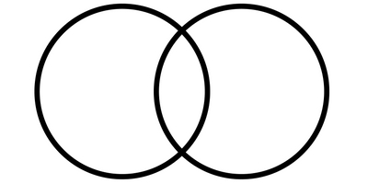

Symbol Name: The Seed of Life

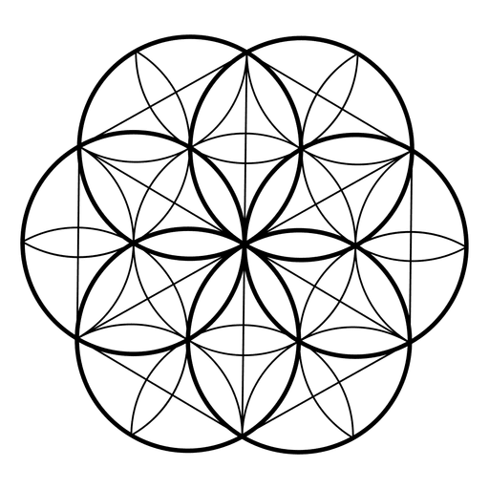

Symbol Name: The Flower of Life

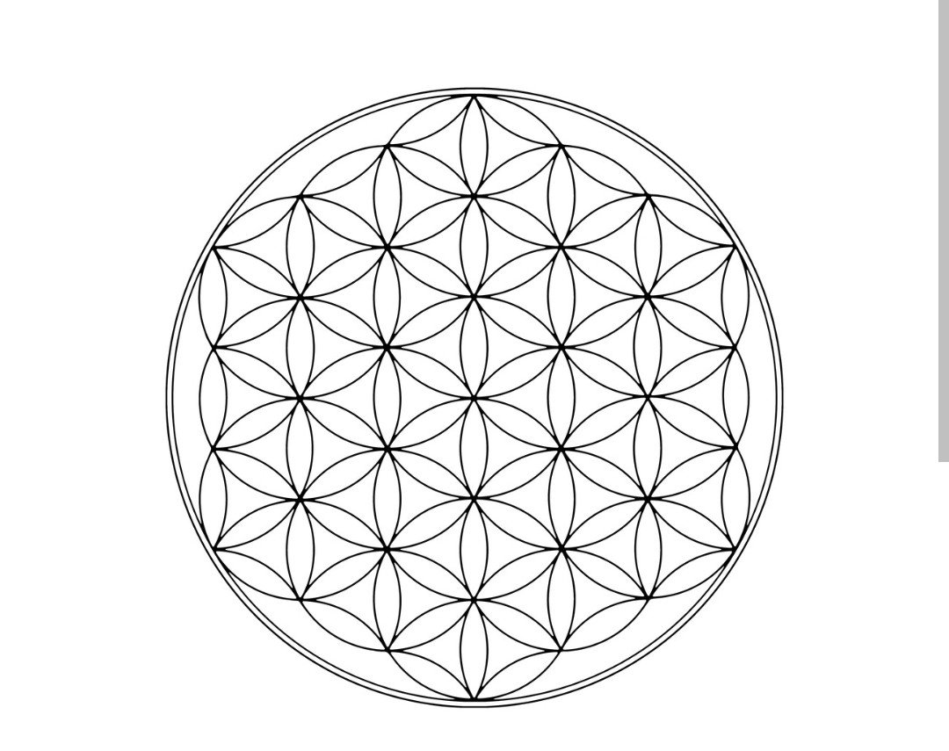

Symbol Name: Vesica Piscis

Symbol Name: Torus

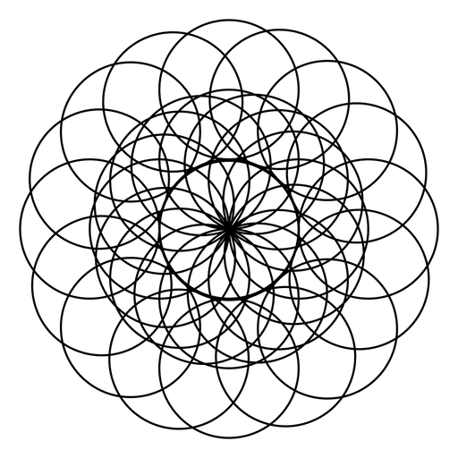

Symbol Name Metatron’s Cube

